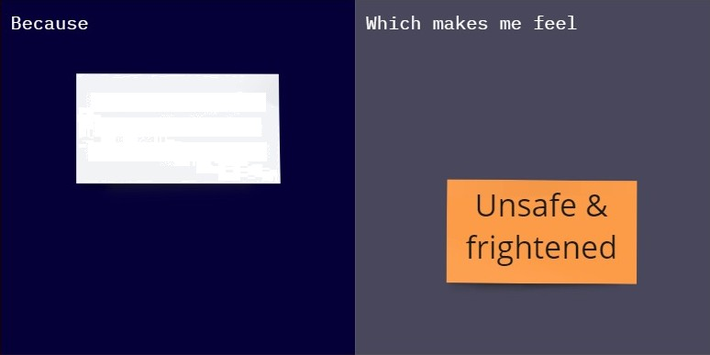

D ue to lack of proper

usage of technology

and safety awareness

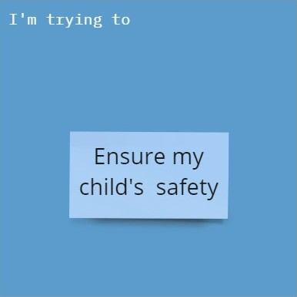A parent There are issues of

child abuse, kidnapping and accident

